GUVI TASK 18

1. Creating EC2 instances in two different regions and installing Nginx using Terraform involves several steps. Below is a detailed guide on how to accomplish this.

Prerequisites:

1. Install terraform using the documentation in your aws ec2 instance.
2. Also install AWS cli and aws configure
3. First create a normal ec2 instance with any AMI .

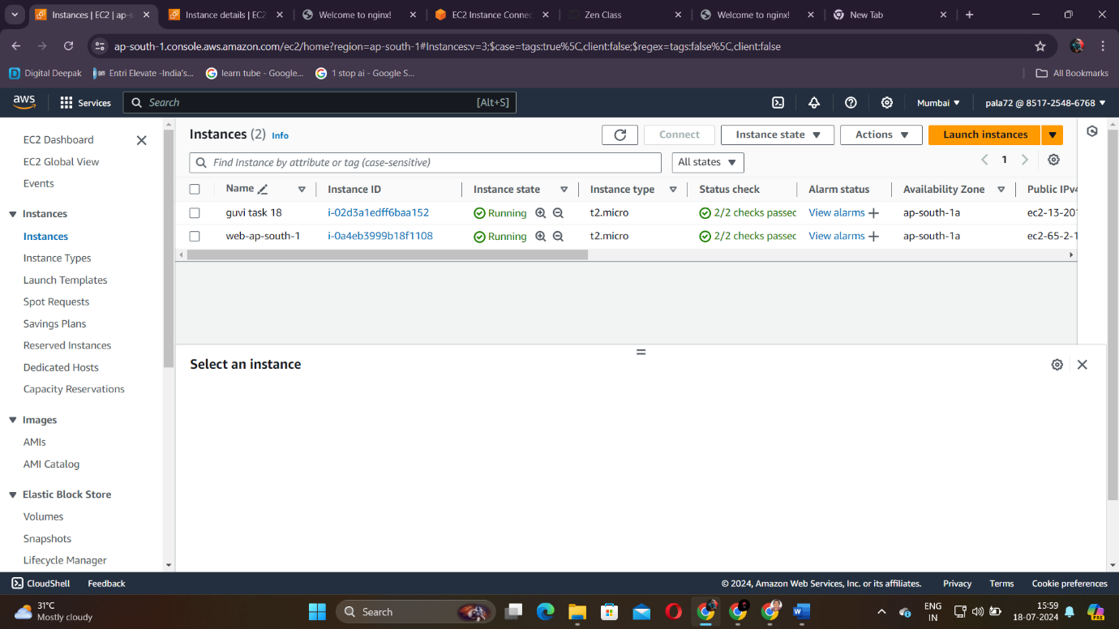

\*guvi task 18

1. After creating ensure you get the prerequisites listed above.
2. Then create a new directory for your terraform project. Then create a configuration file main.tf

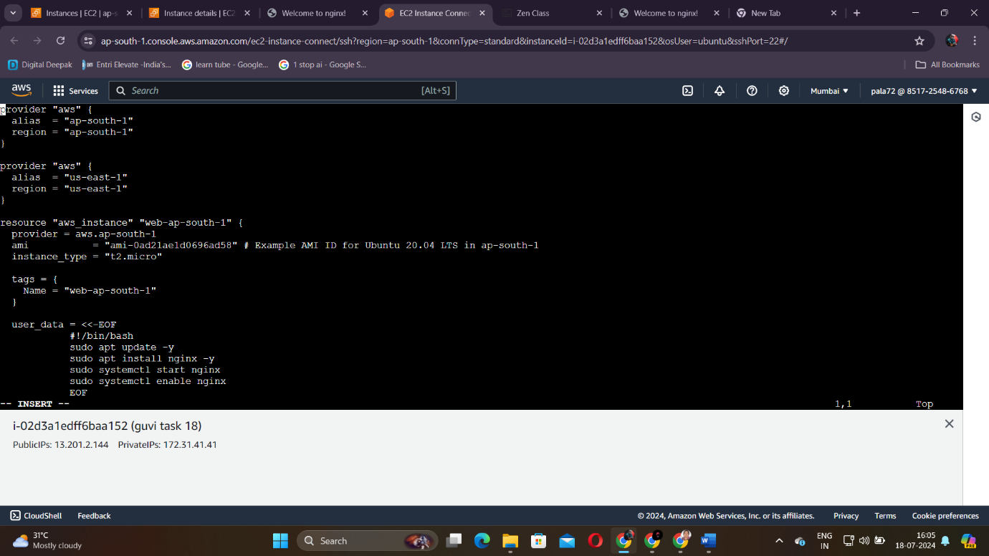

1. Next configuration file is output.tf

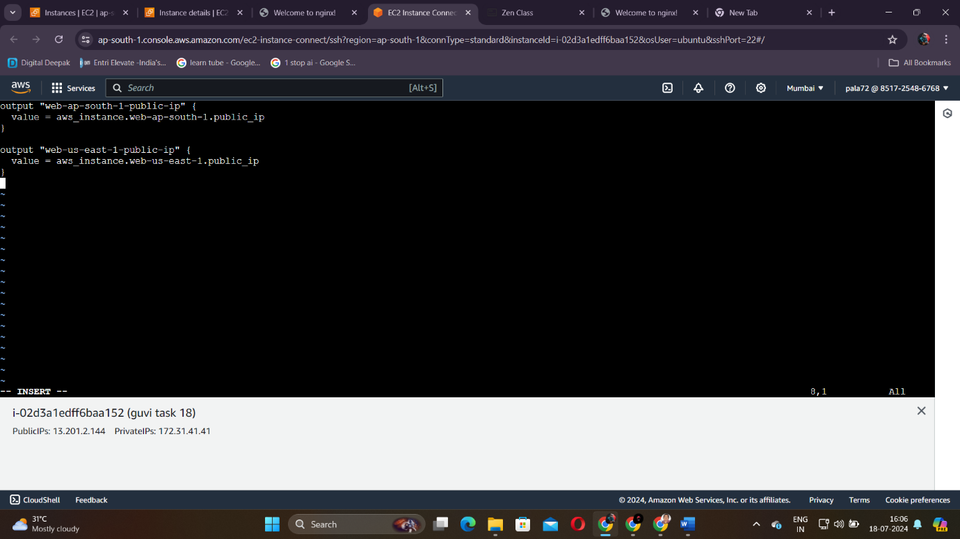

1. Next do the terraform workflow commands as you know each step very well.
2. In the last command terraform apply you get like this

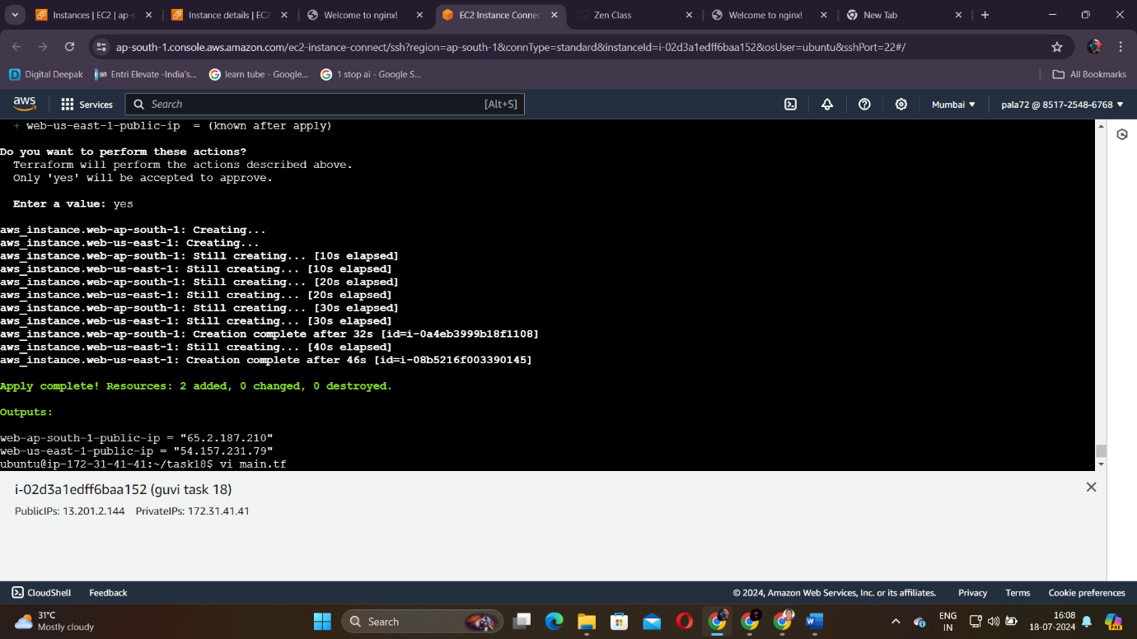

As you see there are two public ip listed from 2 instances. Open each ip in new tab and check whether nginx works. It should be like this,

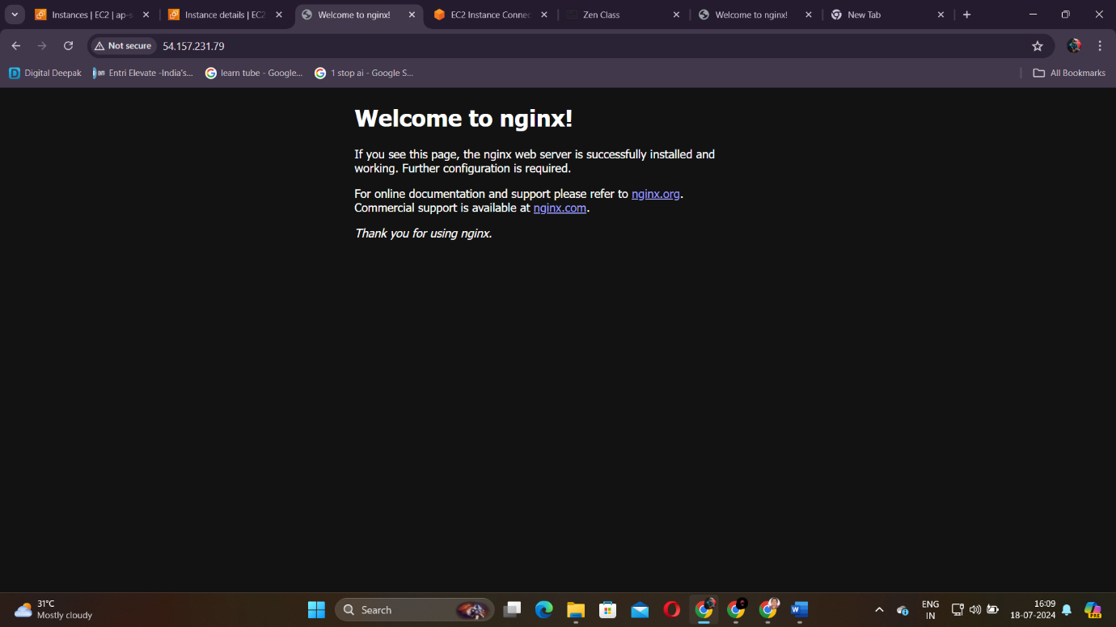

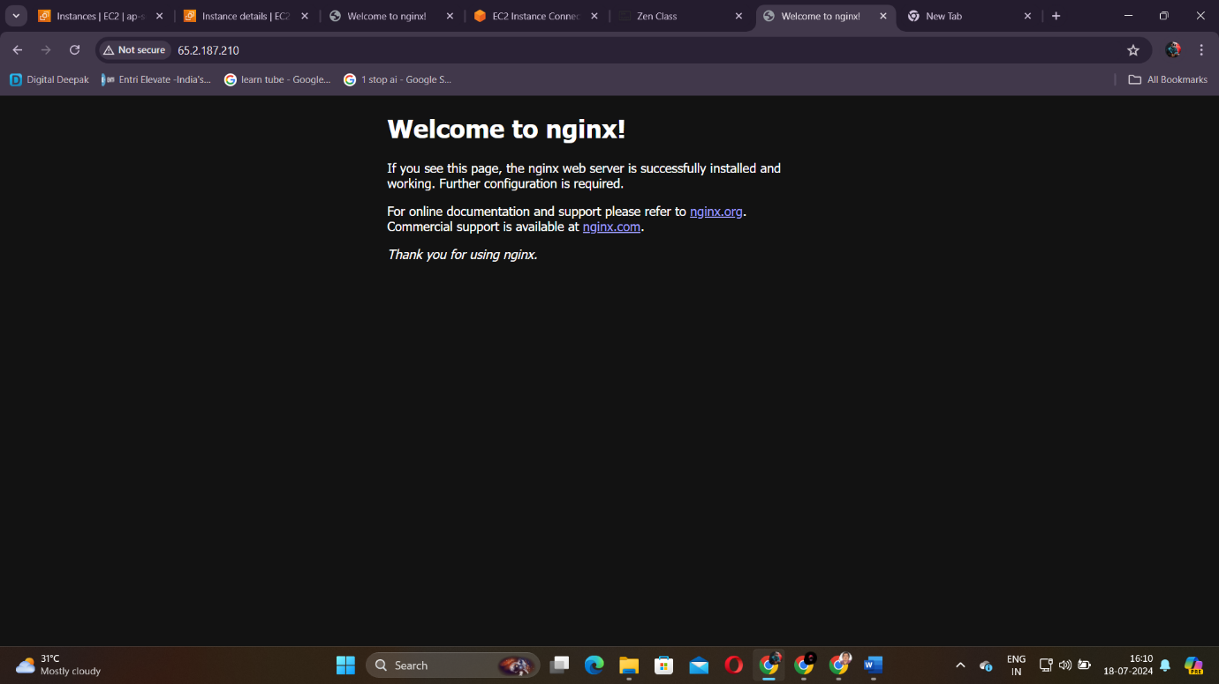

-----X-----